Here are 5 fun activities inspired by The Lorax:
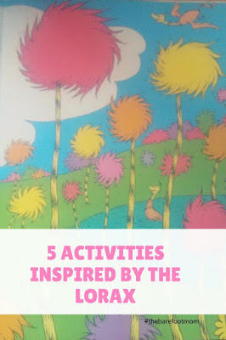

Make a Whisper-ma-Phone:
Make your own whisper-ma-phone just like The Once-ler's.
For this project, you will need:
-2 paper cups
-A non-elastic string 20-30 ft long

Start by poking a small hole in the bottom of each paper cup.

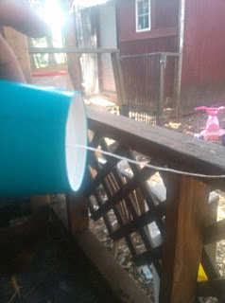
Thread one end of the string through the hole in the bottom of one cup and knot so it can't come out. Do the same with the other end of the string and the other paper cup.
Now you should be able to use it like a phone. Stand with a person at each cup and pull the string taunt. See how quiet you can speak and still hear each other.

Paint A Mural:
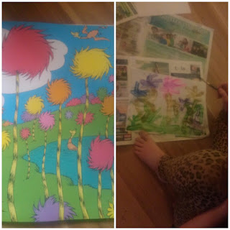
The illustrations in The Lorax are great inspiration for mural painting. My daughter loves to paint Truffula Trees. Grab a large sheet of paper or cardboard and some paint and get creative! If you don’t have paint use what you have markers, crayons, colored pencils, etc. Be creative and have fun!!

Plant A Seed:
Plant your own seed and watch it grow! Instead of a tree though, choose something that grows quickly like beans or peas. Take or draw pictures of the different stages as your plant grows. Use seeds from fruit or veggies that you have eaten or ones that you find outside.
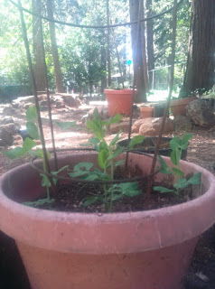
Learn About The Oxygen Cycle:
Plants and trees are vitally important to life on Earth. Plants create a good portion of the oxygen that we breathe through a process called photosynthesis. Plants use energy from the sun and carbon dioxide to produce chemical energy and oxygen. Animals breathe in the oxygen and breathe out the carbon dioxide, and the cycle begins again.

Here are some good resources for teaching children about the oxygen cycle:

-Ducksters: The Oxygen Cycle

-Ducksters: Photosynthesis

-CC Cycle 2, Cabon and Oxygen Cycle video
-Photosynthesis video from Peekaboo Kidz

Movie and a Snack:
In 2012 The Lorax was made into a full length film and it's great! It's one of our family favorites. It's available to rent on Google Play, YouTube, VUDU, Amazon Video, and iTunes.

Make a lorax themed snack to go with it! Here are links to a variety of fun Lorax themed snacks:
Lorax Tangerine Snack from A Few Shortcuts
Truffula Tree Treats from The Seasoned Mom
Babybel Lorax from Cute Food For Kids
The Lorax Munchie Mix from Blue Skies Ahead

If you enjoyed this post check out:
-5 Dr. Seuss Inspired Activities
-My Favorite Children's Picture Books

